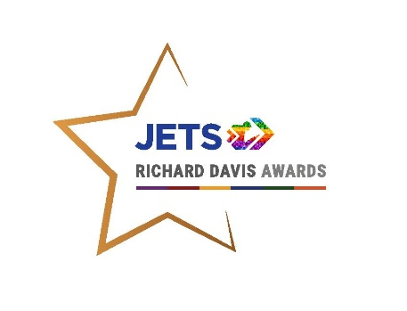 | 

Richard Davis Awards Entry Form - The Jockey Club Achievement Award
Awards Overview
Awards Background
The JETS Richard Davis Awards, now in their 28th year recognise and reward the career development of jockeys, past and present. The Awards aim to highlight some of the best examples of jockeys’ career development and encourage and inspire others to do the same.
The Awards have been running since 1997 and are named in memory of Richard Davis who had begun planning his second career when he was tragically killed in a race fall in 1996.
The Awards are split into 3 categories:
- The Jockey Club Achievement Award (for those who have shown significant achievement in an established business or second career) - £3,000 to the winner, £500 each to the two runners-up
- The IJF Progress Award (for those that have started out or started working towards a second career in the past two years and have shown good progress) - £2,000 to the winner
- The BHA Development Award (Exclusively for currently licensed jockeys who have shown real commitment to their career and personal development, both in and out of the saddle, demonstrating ways in which they have proactively worked towards maximising their career as a jockey and preparing for their second career) - £1,000 to the winner

N.B. Entries for this Award can be submitted by the Jockey Coach.

Submission Details and Deadline: Applications should be emailed to Lisa Delany, JETS Manager lisa@jets-uk.org by Wednesday 27th August 2025. A shortlist will be interviewed by the Judging Panel on 24th September.

Richard Davis Awards Entry Form – The Jockey Club Achievement Award
- Personal Details
Name:

DOB:

Address:

Email:

Phone: Mobile:

- Riding Career
FIRST LICENSED: RETIREMENT DATE (if applicable):
CAREER SUMMARY (Licence(s) Held/Rides/Wins/Big Race Wins:

- Please state any contact you’ve had with JETS (Yes/No– please delete)
JETS Support | Yes/No
Initial Consultation | Y/N
Training Advice | Y/N
Career Guidance | Y/N
CV Preparation | Y/N
General Job Search Assistance | Y/N
Interview Technique Training | Y/N
Recruitment/Work Placement | Y/N
Training Courses (please specify name and date): | Y/N

- What is your chosen second career? What influenced you and made you choose to follow this career path?

- How have you made use of JETS and their services? (Include both during and after your riding career.)

- Please describe the action/career plan you have followed/put into place for your intended career.

- Please describe/outline your long-term aims and aspirations within your chosen career path.

- Based on the judging criteria of effort, forethought and initiative, please state below why you think you deserve to win this Award. Include any events, personal circumstances or challenges faced which you feel should be considered in relation to this award. (max 200 words)

Please answer these questions as fully as possible, in particular it would be useful to point out specific achievements in the last year.

Terms and Conditions:
- Entries must be received by Wednesday 27th August 2025
- A shortlist of three finalists will be selected from the written entries
- The three finalists must be available to take part in a phone interview with the judges in order to be eligible for the winner’s prize.
- The winner receives a cash prize of £3,000
- The two runner-ups will each receive a cash prize of £500
- The winners and runners-up will be notified in October and the winner will be filmed ahead of the Awards ceremony when the winner is announced and they will receive hospitality at Warwick Racecourse on November 4th.
- The judges’ decision is final.
- By entering these Awards, you agree to taking part in publicity for JETS, The Jockey Club and the Richard Davis Awards

I agree to the above Terms and Conditions.
Signed: Date:

